The wage and non-wage practices of NGOs:
innovating to remain competitive

Alexia Tafanelli and Camille Rouxel • Coordination Humanitaire et Développement (CHD)

The professionalisation of the international solidarity sector has clearly not borne fruit in terms of salary levels. But the study presented here shows that employees' expectations also lie elsewhere, and that there is no shortage of ways to attract and retain those who actively seek to get involved.

T

he issue of remuneration and human resources, in the broadest sense, is a major concern for non-governmental organisations (NGOs), largely because of the increasing professionalisation of the French international aid and development sector which, by its very nature, is multifaceted. Constantly evolving, it features a wide variety of organisational models and different ways of working (from voluntary work to salaried employment on several types of contract: part-time, remote working, etc.). Furthermore, these considerations have a strategic dimension because of the problems of attracting staff to NGOs, which are constantly striving to innovate in order to recruit and retain the best talent to serve their cause. The wage and non-wage practices of organisations are therefore the subject of analyses, comparisons and even competition within the associative sector itself and within the general labour market.

Despite being a subject of major concern, the human resources of the international aid and development sector have been the focus of very little research. In 2009, a study focusing exclusively on remuneration was conducted by Coordination d’Agen. Another study, carried out by Taste in 2014, updated and extended the analysis of remuneration to the non-profit sector. Although pioneering in their field, these studies nonetheless have their shortcomings, and a new one was needed to update the data. Furthermore, to address the challenges relating to the professionalisation of the sector, it seemed essential to broaden the analysis to non-wage practices whilst adding new, contemporary issues to the equation (gender, remote working, soft mobility, etc.). In order to address the issues faced by organisations, it also seemed essential to carry out a study that would help underpin arguments about wage and non-wage practices, whilst including the new challenges facing the sector and to which it must adapt. It was against this backdrop that Coordination Humanitaire et Développement (CHD), with the support of Deloitte, decided to carry out a study on the wage and non-wage practices of French NGOs. A founder member of Coordination SUD, CHD is a French international aid and development group that brings together fifty-six organisations involved in the field of humanitarian aid and development. Given that it strives to unite and coordinate field actors and promote their distinctive features to private and public partners, it was entirely appropriate for CHD to carry out this study, which is fully in line with its mandate. CHD’s aim in launching the study was to provide NGOs with a clearer idea of their current wage practices and help them implement more effective wage policies aligned with their culture, operating methods and strategic objectives. The study also aimed to monitor competitors’ current trends and emerging practices. According to Yolaine Guérif, director of the association Partage and member of the steering committee in charge of ensuring that the study was carried out properly and in compliance with its guidelines, “The aim was to have a common baseline for fairer remuneration”. Furthermore, the study was intended to become a strong tool for advocacy with public authorities, highlighting the effects that institutional decisions have on the international aid and development sector: “We also hoped that disseminating this study among the public authorities would change the budget framework of State-funded programmes,” said Delphine Hugues, Human Resources Manager of La Guilde and member of the study’s steering committee.

In this article, our aim is to provide the sector with food for thought about these issues based on the major trends and practices highlighted in the study. Based on a sample of fifty-eight organisations with a variety of social missions, sizes and budgets, the aim was to ensure a balanced representation of the sector whilst still taking account of the specific characteristics of small and medium-sized NGOs. Thus, 16% have a budget under 500,000 euros, and 10% a budget of over 30 million euros. In terms of their workforce, 22% of the organisations have fewer than ten employees, and 16% have more than eighty. The population covered in this study includes employees on permanent and fixed-term contracts, based in France or posted abroad, amounting to 8,557 employees, 39% of whom are managers and 61% non-managers.

Fragile competitiveness compared with the general market

One of the reasons why organisations have difficulty attracting and, above all, retaining talent seems to be remuneration. On average, employees in the sector are paid less than the median amounts observed in the general market: -19.3% for non-managers and -35.4% for managers (total remuneration). The latter are well below the market average, with median levels below the first decile of the general market. The greater the level of responsibility, the greater the loss of competitiveness. Furthermore, as employees move up the ladder of responsibility, there is very little salary growth: between the top 10% and the bottom 10% of the sample group’s salaries, the ratio is 2.05 for total remuneration, compared with 3.07 in the general market. This limited scope for growth, which mainly concerns small and medium-sized organisations, has an effect on talent retention. “We have difficulty retaining these resources in the long term because we are limited in our wage growth,” said Delphine Hugues. Moreover, for an equivalent status, all sectors of the profession have a lower positioning than the general market. “We have difficulty recruiting for support functions such as financial and administrative services because the competition is much stronger and the salaries higher in the commercial market,” said Delphine Hugues.

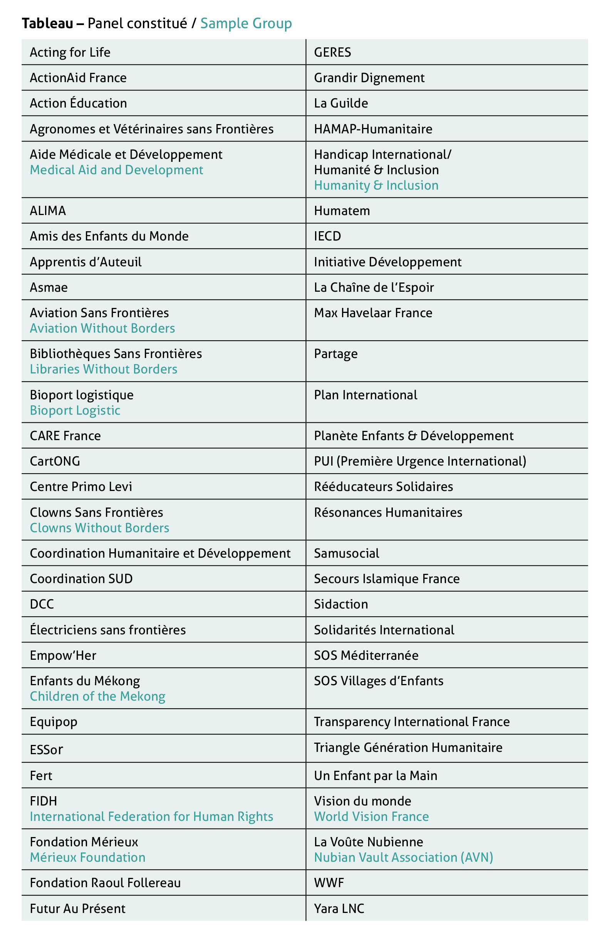

In-house pay parity issues

External competitiveness aside, organisations face in-house parity issues, i.e. ensuring that jobs with similar requirements are remunerated on an equivalent basis within the organisation. Indeed, the sector has disparities in remuneration for equivalent levels of responsibility that exceed the general trend: 12% of non-managers and 28% of managers are outside the parity zone. These differences can be explained by the different sizes of the organisations and the case-by-case arrangements that may exist when there is no pay scale. One example is gender-based pay inequality – the international aid and development sector is no exception in this respect, even if the differences are smaller than in the general market. Indeed, on average, women earn 1.5% less than men, compared with 3.7% less for the general market. Guided by values of social justice, equality and human rights, organisations foster an organisational culture that is mindful of gender equality and adopt fairer remuneration policies. Nonetheless, at the highest level of organisational responsibility, men’s overall remuneration is 16.1% higher than that of women. The wage gap aside, the glass ceiling in the international aid and development sector is clearly visible: women are strongly represented at non-managerial levels, but increasingly less so as the level of responsibility rises. They are even in the minority at management level.

Boosting mobility and expatriation policies despite the constraints

Retaining talented staff also involves valuing and boosting their professional career path through in-house and geographical mobility. Even though organisations are aware of the challenges involved with communicating and implementing mobility policies, the effectiveness of these policies can be limited because of the size of the structure, as pointed out by Delphine Hugues: “There are thirty-five of us, so there are fewer opportunities for development and mobility when compared to larger structures... even though we do our best to provide such opportunities, develop posts and foster in-house promotion.” With regard to geographical mobility, two-thirds of the NGOs have difficulty recruiting expatriate staff. Combined with a context in which the opportunity to work overseas is no longer considered to be a model of fulfilment for employees, organisations feel that unattractive remuneration packages are a major stumbling block.

Social benefits and the working environment: key levers for standing out from the crowd

In order to attract and retain the best talent, organisations promote so-called total remuneration strategies that include non-salary components. “Even though remuneration is below the general market level, at Partage we adopt a remuneration strategy that is more total in scope. This translates into benefits such as gift vouchers and the sustainable mobility package, a financial allowance that encourages the use of more sustainable modes of transport; but it also involves promoting a good work-life balance,” said Yolaine Guérif. Smaller organisations, however, have limited room for manoeuvre when it comes to offering an attractive total remuneration package as they struggle to match the resources available to larger organisations. Another benefit widely adopted by organisations is remote working, which allows flexible working arrangements – an essential criterion for employees. Placing these benefits at the forefront of HR strategies seems to be effective, as shown by employee satisfaction. “As part of our 2022–2025 HR strategy, we developed a pay scale, and introduced an agreement about working from home and a sustainable mobility package. This has been a great success, as the proportion of employees who are ‘somewhat satisfied’ or ‘satisfied’ has increased from 16% to 72%,” said Yolaine Guérif.

The study as a catalyst for change

CHD’s study has therefore highlighted these challenges of attracting and retaining talent as the sector becomes increasingly professional. Sharing wage and non-wage practices provides organisations with visibility, meaning that they can adopt a position and compare themselves with each other and with the general market. For some, this has resulted in new human resources management tools and more attractive total remuneration. “In-house, the study has provided us with a reference tool enabling us to build a pay scale and, ultimately, strengthen our transparency and accountability to our employees, the CSE [works council] and all our stakeholders,” said Yolaine Guérif. For La Chaîne de l’Espoir, “the study has allowed me to produce a remuneration benchmark in order to provide the organisation with its first pay scale,” said Laure Lengaigne, Director of Human Resources at La Chaîne de l’Espoir and member of Cercle RH [HR Circle]. “The study has allowed us to justify our calls for general wage increases, an unprecedented action in the history of the association,” said Delphine Hugues.

The implementation of these specific actions aside, the study has highlighted a number of areas for further reflection and observations that organisations of all sizes need to consider in order to continue developing their practices. Thus, from an in-house parity and attractiveness point of view, organisations are aiming to improve the competitiveness of their practices, develop appropriate management tools and boost career paths in order to retain their talent.

In order to stimulate the debate around these themes, CHD has set up a discussion forum for organisations wishing to boost their capacities and share their practices. “In a sector with very specific regulations and employment law, the Cercle RH allows us to share best practices and help each other deal with common issues. We are coming out of the isolation that our job as HR managers can impose on us, and this is allowing us to learn from each other’s experiences,” said Laure Lengaigne. For almost two years now, the Cercle RH has been holding quarterly workshops to share knowledge and discuss practices on topics such as how the HR function is organised within NGOs, innovative working methods and how organisations can strengthen their in-house and external parity. Each session is run by a leading expert in the subject in question, or features a presentation of their practices by one or more organisations. As part of a forward-looking approach to addressing the future challenges of professionalisation, the Cercle RH recently came across a new topic: the use of artificial intelligence by international aid and development organisations. “The humanitarian sector is way behind in terms of innovation. We have a long way to go, but we are starting to ask ourselves questions and educate ourselves,” said Laure Lengaigne. Even though this tool is a great potential resource for the HR sector (and support functions in general), its practical and ethical limits are being questioned at these workshops. This need for organisations to innovate and share their practices in order to offer attractive total remuneration for talented staff is still, therefore, and will continue to be, a challenge.

In addition to its unifying effect, which is conducive to the professionalisation of the sector, this study offers undeniable ways of raising awareness and communicating. From an advocacy point of view, these exchanges allow greater transparency vis-à-vis public and private partners, and allow CHD, as well as the member organisations of the Cercle RH, to advocate for an increase in structural costs in order to develop organisations’ international activities. Keen to pursue its commitment to supporting those involved in international aid and development, and in order to measure how practices have changed, CHD plans to repeat the study in 2025 and will open it to the entire sector.

Translated from the French by Derek Scoins

Biographies

Alexia Tafanelli • Alexia Tafanelli, a graduate in political and international affairs from Queen Mary University of London, began her career at Solidarités International and Save the Children in programme and advocacy positions. In 2021, she coordinated the Enfance [Childhood] working group of Coordination Humanitaire et Développement (CHD) and is now its director.

Camille Rouxel • Camille Rouxel, a Master’s student in international politics, is currently on her end-of-study work placement in CHD’s executive division. During her studies, Camille has worked on migration and international governance issues.

Reproduction prohibited without the agreement of the review Humanitarian Alternatives. To quote this article:
Alexia Tafanelli and Camille Rouxel, “The wage and non-wage practices of NGOs: innovating to remain competitive”, Humanitarian Alternatives, no. 26, July 2024, pp. 51–60,

https://www.alternatives-humanitaires.org/en/2024/07/10/the-wage-and-non-wage-practices-of-ngos-innovating-to-remain-competitive/

Towers Watson, Coordination d’Agen. Baromètre des pratiques salariales des ONG, 2010
Deloitte et Taste, Étude sur les Rémunérations Individuelles – Associations et Fondations, Observatoire de la Rétribution, février 2014, https://www2.deloitte.fr/documents/Etude_Remuneration_NonProfit_022014.pdf
Coordination Humanitaire et Développement, Étude des pratiques salariales et extra-salariales des ONG françaises, Deloitte, 30 novembre 2022, https://www.c-hd.org/pdf/pm_mod_files/etudes/pdf_etudes.pdf
The “parity zone” includes the zone between -/+10% of the median; beyond these limits, there is a risk of inequity. In-house parity is measured by the percentage of employees outside this parity zone.

